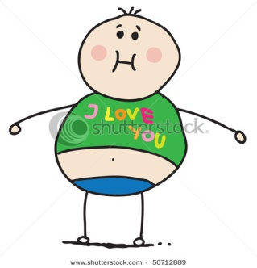**Could My Child Be Overweight?**

**Obese? Or Under-Nourished?**

**Did you know that almost 30% of Australian parents don’t know their child is overweight!!!**

**What is:**

**Overweight -** Too much fat on their body for their height and age.

**Obese -** a severe form of overweight.

**Under-nourished -** not enough vitamins/minerals and body movement to grow up healthy and smart, and get the best start in life!

**Is this true?**

**A fat baby is a healthy baby** – It depends! Babies need to gain weight at a pretty fast rate, but rolls and rolls of fat can be a problem. Check with a Child and Family Health nurse, family worker or age/weight baby charts.

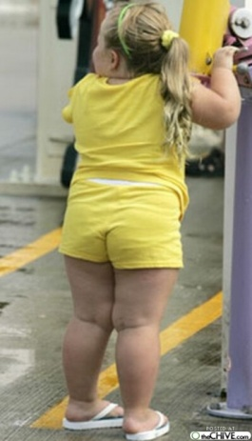**It’s only puppy fat** – No! Most overweight children are very likely to become overweight adults.

**Kids will ‘grow into’ their weight** – No! They would need to grow taller but not gain more weight.

**Overweight can be caused by having big bones or a slow metabolism** – No! There is very little difference in bone weight or metabolism in kids.

**Overweight can be caused by genetics** – This is **rare**! Usually unhealthy eating and not learning to move are ‘passed down’ through the family.

**Dieting is the best way to bring weight down to a healthy level** – No! Kids just need the right types of food and drinks, and more movement, not less food and drinks. Little changes – over a long time - as they grow up ☺

**Changing eating habits can lead to eating disorders** – No! Learning how to eat and drink healthier, move and play every day as a child, gives your child a healthy attitude to food and being active for the rest of their life.

**Why is my child overweight or obese and under-nourished?**

My child is:

* **eating and drinking too much unhealthy food** – lots of sugar, fat and salt - like crumbed and fried food; packaged food – like noodles, chips, cornchips, crackers; sweet food like biscuits, lollies, chocolates, snack bars, and sweet drinks like soft drinks, cordial, fruit juice, etc –
* **not eating enough healthier foods** – like meat, fish, chicken, low fat milk and cheese, fruit, vegies, rice and oats, etc
* **not drinking enough water every day**
* **sitting still and laying around too much** - watching TV, DVDs and computer games.
* **not moving their body enough** – walking, crawling, climbing, hanging, dancing, running and playing physical games

**[1 in 4 children are overweight](http://www.aihw.gov.au/*/)**My child is between 2-5 years old - 1 in every 5 kids are either overweight or obese and under-nourished.

**[1 in 4 children are overweight1 in 4 children are overweight](http://www.aihw.gov.au/*/)**

My child is school aged - 1 in every 4 kids are either overweight or obese and under-nourished.

**[1 in 4 children are overweight1 in 4 children are overweight](http://www.aihw.gov.au/*/)**

If your child is 0-2 years old – talk to a Child and Family Health nurse, Home-Start worker or check the standard charts**.**

**Adapted from:**[**Raising Children Network**](http://raisingchildren.net.au/articles/childhood_obesity.html/context/245)

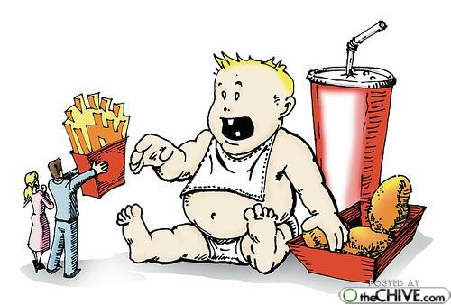**www.raisingchildren.net.au**